{$ Issuing Date}

{$ STUDENT NAME}
{$ Student Address}

Dear Graduand

COMPLETION OF COURSE OF STUDY
{$ STUDENT NAME} (NRIC/Passport No. : {$ Identification Number})

- Congratulations on the successful completion of your course of study!

- We are pleased to inform you that you will be awarded the {$ Course Name – Certification (without annotation)} at the Graduation Ceremony scheduled in May {$ Graduation Year}.

- We wish you all the best in your future endeavours.

Yours sincerely
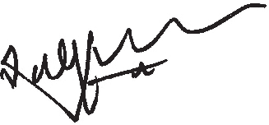
SNG CHOON LENG
Director, Academic Affairs

